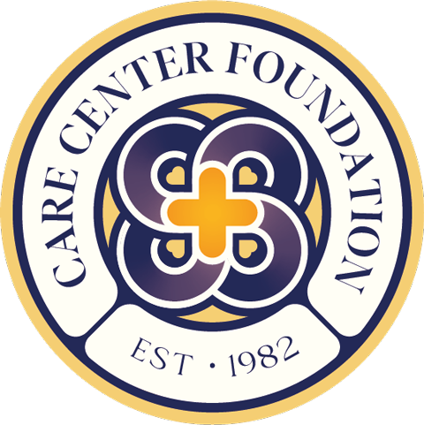 | Care Center Foundation  TheCareCenterFoundation@gmail.com  www.carecenterfoundation.org  127 S. Matlack St, West Chester, PA  (610) 436-6226

Child Care Assistant Job Description

Reports to: Daycare Director
Supervises: No supervisory responsibility
Salary Range: $15 - $20/hour based on experience and qualifications

Organizational Overview:
The mission of the Care Center Foundation (CCF) is to promote community partnerships by providing a ministry of presence and spiritual support in the West Chester, PA community that it serves. The CCF empowers those who give and those who receive through creative educational, recreational, and social service activities. The CCF was founded in 1982 by Rev Carl Guthrie and Dr. Gary Cashon. On a downtown West Chester corner where drugs and violence were commonly encountered, they created an organization where families could find opportunities, community, and hope for a better future.

Today, as a nonprofit organization, CCF is dedicated to providing high-quality childcare services to families in the West Chester community and supplementing that care with opportunities for the families to grow and thrive.

Description:
We are looking for a Child Care Assistant to be responsible for maintaining a safe and fun environment for the children at the Care Center. The applicant must enjoy working with and be able to responsibly supervise children within the daycare setting. Additionally, the applicant should be able to encourage positive healthy growth, both physically and intellectually.

Job Responsibilities:
- Care for overall the well-being of the children
- Monitor children at all times during hours of operation to ensure that they play and interact with one another safely and appropriately
- Ensure children have good hygiene and assist with washing hands, brushing teeth, etc.
- Must be able to change diapers as necessary
- Clean interactive areas of the daycare throughout the day
- Prepare meals and snacks for the children
- Help plan, organize, and execute developmentally appropriate activities

- Contact the children’s parent/guardian in case of an emergency
- Provide support for lead teacher(s) and assistant teacher(s) as needed
- Maintain a safe and positive environment at all times

Requirements and Qualifications:
- High school diploma or equivalent.
- Must have current criminal history, child abuse, and fingerprint clearances
- Must be a Mandatory Reporter
- A certificate in early childhood education and care (CHC 30113)
- A current Working with Children License
- First Aid Training
- On-the-job Training
- Basic computer literacy
- Excellent communication
- Must meet state-specific guidelines
- Proficiency in Spanish a plus, but not required

Hours of Operation:
- Hours of operation are 7:00 am – 5:00 pm, Monday through Friday.
- Child Care Assistants will be scheduled on an hourly basis.
- Staff members are given a one-hour break (on or off-site) when working
5 or more hours in one day
- Compensation for work over 40 hours a week will need approval from the
Board of Directors
- CCF follows the West Chester Area School District for closures

Personal Characteristics and Work Style:
- Commitment to excellence, innovation, collaboration, and inclusivity consistent with CCF’s approach to program development and implementation
- Sincere passion for and understanding of the organization’s mission and
commitment to families
- in our community; ability to be a compelling ambassador for the organization’s values
- Collaborative and engaging communication style in working with people of
many backgrounds,
- including families, leaders, staff, volunteers, and donors
- Ability to multitask and balance multiple priorities in a complex and multi-faceted program
- Unfailing discretion in dealing with sensitive material about families

CCF is an Equal Opportunity Employer and does not discriminate on the basis of age, disability, sex, race, religion or belief, gender reassignment, marriage/civil partnership, pregnancy/maternity, or sexual orientation. We welcome all applications from a wide range of candidates. Selection for roles will be based on individual merit alone.

