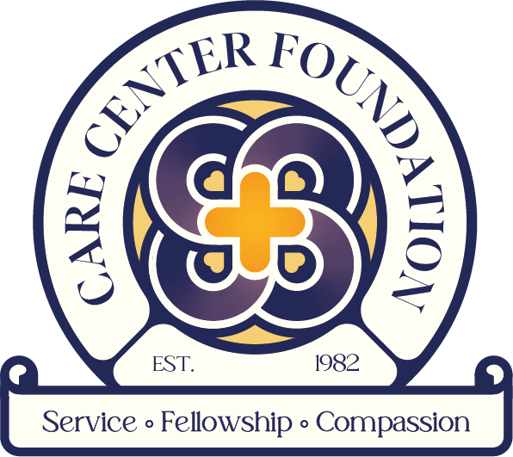
Care Center Foundation
TheCareCenterFoundation@gmail.com
www.carecenterfoundation.org
127 S Matlack St, West Chester, PA
(610) 436-6226

Daycare Director Job Description

Reports to: President of the Board of Directors and CCF Nonprofit Director

Supervises: All Child Care staff

Salary Range: Based on experience and qualifications

Organizational Overview:
The mission of the Care Center Foundation (CCF) is to promote community partnerships by providing a ministry of presence and spiritual support in the West Chester, PA community that it serves. The CCF empowers those who give and those who receive through creative educational, recreational, and social service activities. The CCF was founded in 1982 by Rev Carl Guthrie and Dr. Gary Cashon. On a downtown West Chester corner where drugs and violence were commonly encountered, they created an organization where families could find opportunities, community, and hope for a better future.

Today, as a nonprofit organization, CCF is dedicated to providing high-quality childcare services to families in the West Chester community and supplementing that care with opportunities for the families to grow and thrive.

Description:
CCF is looking for a passionate Daycare Director to be responsible for overseeing the daily operations of the Care Center Foundation and ensuring that children have a safe and fun environment in which to learn and socialize. Duties include assisting in the hiring process of qualified staff, setting budgets for toys and supplies, and proactively communicating with parents to accommodate their child’s needs and maintain a relationship.

Job Responsibilities:
- Oversee daily workflow, scheduling, ratios, supervision, and school operations.
- Train, coach, and evaluate teachers, assistant teachers, and other staff and/or volunteers.
- Work with the Lead Teacher to manage all aspects of daycare programming
- Promote communication and cooperation with children, staff, families, etc.
- Stay current on required personnel file items, training, and certifications, and be sure to understand any procedures regarding these areas.
- Be competent and current in First AID/CPR Training, Water Safety, and Fire Safety protocols and regulations.
- Report any suspected abuse immediately.
- Plan both long and short-range activities following curriculum objectives.
- Encourage and oversee the preparation of weekly lesson plans by the Lead Teacher
- Coordinate after-school programming and outreach to the community
- Maintain daily open, proactive communication with the parents/guardians
- Hold weekly staff meetings
- Create a work environment for all staff based on support and mutual care
- Keep all appropriate records such as children's medical files, attendance sheets, and timesheets for volunteers

Requirements and Qualifications:
- Minimum of 3-5 years of experience working in a childcare center with managerial experience at the minimum level of Lead Teacher.
- Master of Education degree required
- Must have current criminal history, child abuse, and fingerprint clearances
- Must be a Mandated Reporter
- Must be aware of childcare regulations and subsidized childcare.
- Must have worked in PA child care licensing inspectors.
- Be familiar with creating and managing budgets
- Proficiency in Spanish a plus, but not required

Hours of Operation:
- Hours of operation are 7:00 am – 5:00 pm, Monday through Friday.
- The work schedule is flexible based on the ability to manage the operation of the facility.
- This position is salaried and exempt
- CCF follows the West Chester Area School District for weather-related closures

Personal Characteristics and Work Style:
- Commitment to excellence, innovation, collaboration, and inclusivity consistent with CCF’s approach to program development and implementation
- Sincere passion for and understanding of the organization’s mission and commitment to families in our community; ability to be a compelling ambassador for the organization’s values
- Collaborative and engaging communication style in working with people of many backgrounds, including families, leaders, staff, volunteers, and donors
- Ability to multitask and balance multiple priorities in a complex and multi-faceted program
- Unfailing discretion in dealing with sensitive material about families

Benefits:
- Benefit package begins after first 90 days of employment and includes paid holidays. Vacation time is offered on an accrual basis.

CCF is an Equal Opportunity Employer and does not discriminate on the basis of age, disability, sex, race, religion or belief, gender reassignment, marriage/civil partnership, pregnancy/maternity, or sexual orientation. We welcome all applications from a wide range of candidates. Selection for roles will be based on individual merit alone.

